10.71: a) Because there is no vertical motion, the tension is just the weight of the hoop:
b) Use 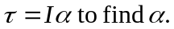The torque is
c) 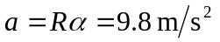
d) T would be unchanged because the mass M is the same, 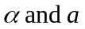would be twice as great because I is now 